What’s On 2022
The main entertainment programme takes place between 10am and 4pm. Some activities are all day and others take place on and off throughout the day.

Giant Beach
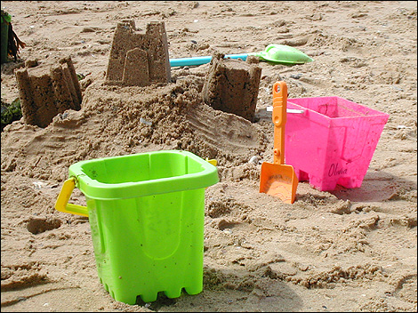
A giant beach laden with plentiful deckchairs and beach toys will descend on Risca Park offering a safe environment for a day of beach fun to keep everyone amused. Bring your picnics, buy off the onsite concessions or #ChooseLocal and support the town centre retailers.

Punch & Judy
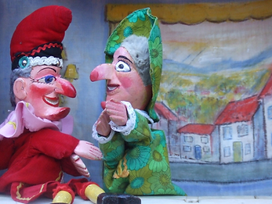
Regular Punch and Judy shows will take place throughout the day from on the beach by Mister Chris! A modern edition of the traditional show will be performed to keep up with the times but still using the same characters and traditional dress.
Show times are 11am, 1pm and 3pm each day.
www.lovegrovem.wix.com/misterchris
Facebook:
Giant Deckchair
Hop onto this giant deckchair and have a picture taken. Share your pictures on Facebook and Twitter @visitcaerphilly.

Donkey Rides
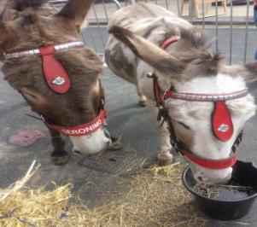
Children just love these furry animals. Free riding available all day!

http://www.mikesdonkeys.co.uk/

Stallholders
There will be a small number of stalls selling sweets, brownies, and Welsh cakes, as well as hot and cold drink refreshments, potato twisters, dinky donuts and the all-important ice cream van!

Funfair Rides & Attractions
There will also be a traditional funhouse, inflatables, trampolines and cups and saucers to keep the little ones amused.

Falconry UK
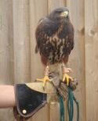
Birds of Prey will be on display for visitors to look at, have photographs with and to learn about the fascinating facts and background of these amazing creatures.
Website: www.falconry-uk.org
Facebook: /FALCONRYUK

(All information subject to change. The information is correct at the time of production)

